**PROBLEM:** Design and build a structure that meets or exceeds specifications while maximizing overall profit.

**SPECIFICATIONS FOR TOWER:**

* Must be at least 36 in. tall ($100000 dollars awarded for minimum height. Extra $2000 awarded with each additional inch)
* Must hold at least 10 pennies at a minimum height of 36 in from the base of the tower (Extra $500 awarded per additional penny)
* Structure must be build within 25 minutes. (Penalty of -$2000 per minute over the time limit. Extra $1000 awarded for each minute under the time limit)

**GIVEN COSTS:**

* 1 3” x 5” index cards costs $1000
* A 100 card limit
* Tape is $5000 per role
* Scissors cost $5000 per pair
* Rulers are free

**ORIGINAL SKETCH:**

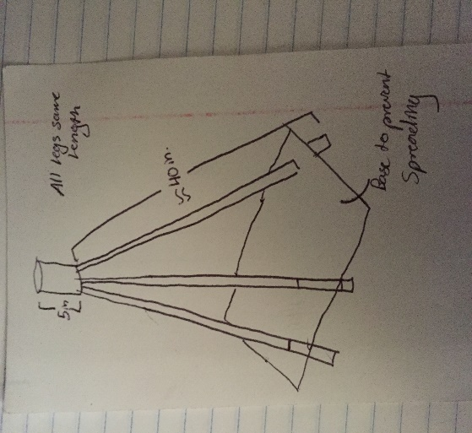

**METHOD:**

In order to minimize the amount of index cards in total we used in construction, we decided to base our design around three triangular shaped pillars rising to a point at the top, similar to a tripod. This is because a triangle is one of the most structurally sound geometric shapes, and would do the most to prevent bowing/bending of the columns. Additionally, we concluded that if we cut the index cards in half, we could effectively double the amount of columns received per individual card, thus cutting in half the amount of cards we would need if each section of the column was a single card.

To determine the amount of cards we would need overall for construction, we took the overall minimum height the structure would have to attain, 36 inches, and divided it by the long side of the index card, 5 inches. This yielded 7.2 index cards, but divided in half due to cutting the cards in half yields 3.6 cards. We added one to this number to account for possible error, and multiplied this by the amount of legs we would construct (3), which yielded 13.8, rounded up to the nearest card 14.

Additionally, we decided to construct a cylinder at the top of the tripod to hold the coins, as well as a base-like structure to prevent the legs from spreading due to low friction with the table the tower sat on. This added an additional 4 cards, giving a total of 18. In order to account for possible errors in calculations and/or mistakes made in construction, we decided to order a total of 35 cards, costing a total of $35000. We also purchased scissors and tape, bringing our total cost to $45000.

**PROCEDURE:**

* Divide 14 index cards into 8 equal sections long ways using ruler
* Cut these cards down the middle and fold each half along lines, creating triangular columns
* Connect roughly 7 to 8 of these columns together by sliding them into each other, securing them with tape
* After all three columns are made, create the base by taping two index cards together in a T shape, cutting holes near each “corner” of the T
* Slide each column into a separate hole in the base, taping the columns together at the top and sliding the base up and down until an ideal spread of the columns is achieved
* Create the top cylinder using 1 - 2 index cards rolled up and taped together, then placed on the top of the tripod and secured with tape
* 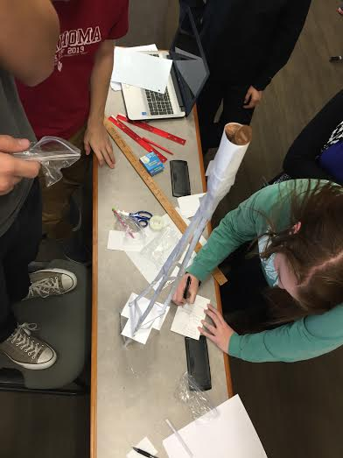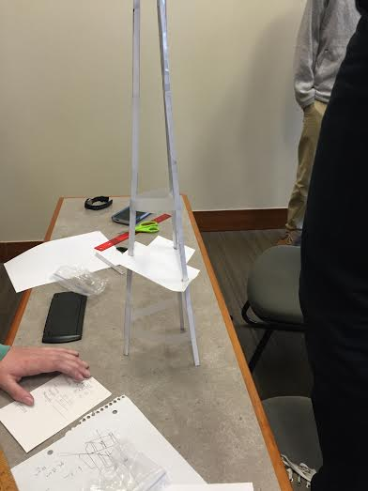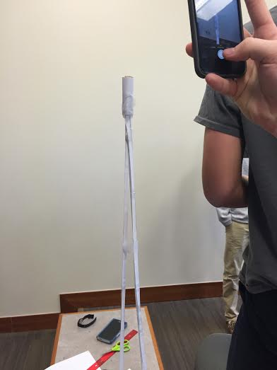For additional support, add tape “tension wires” around the legs of the tripod to prevent any possible spreading not stopped by the base.

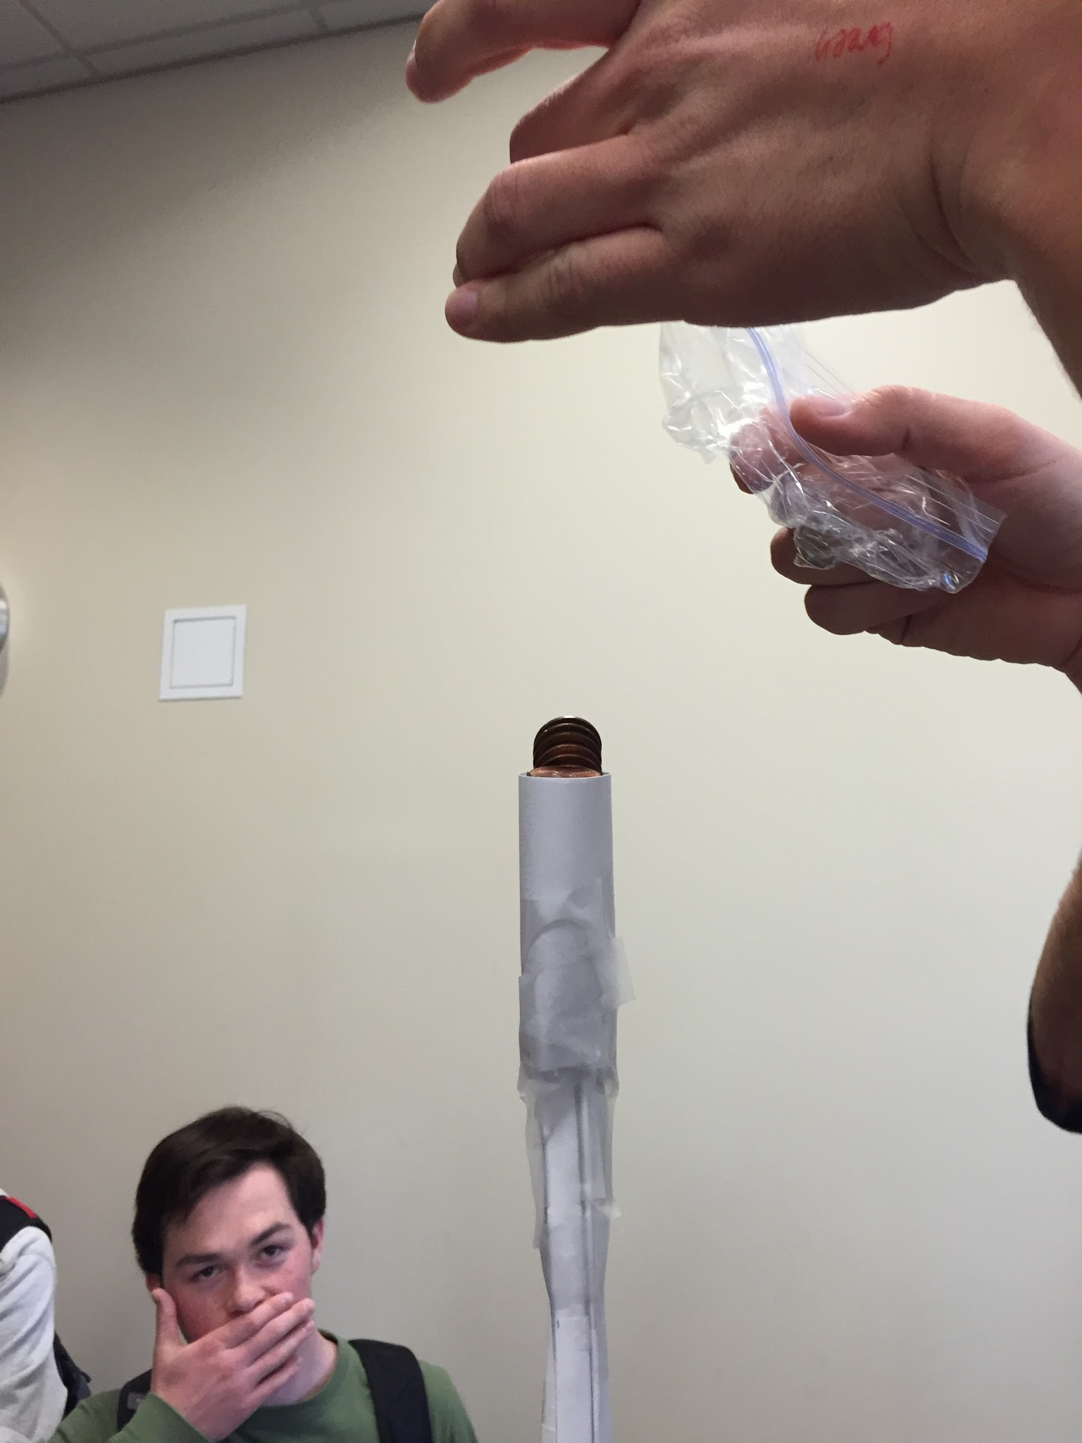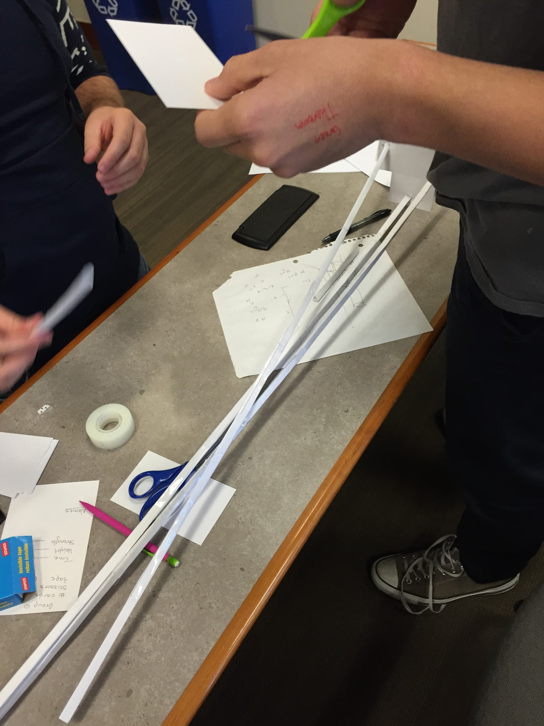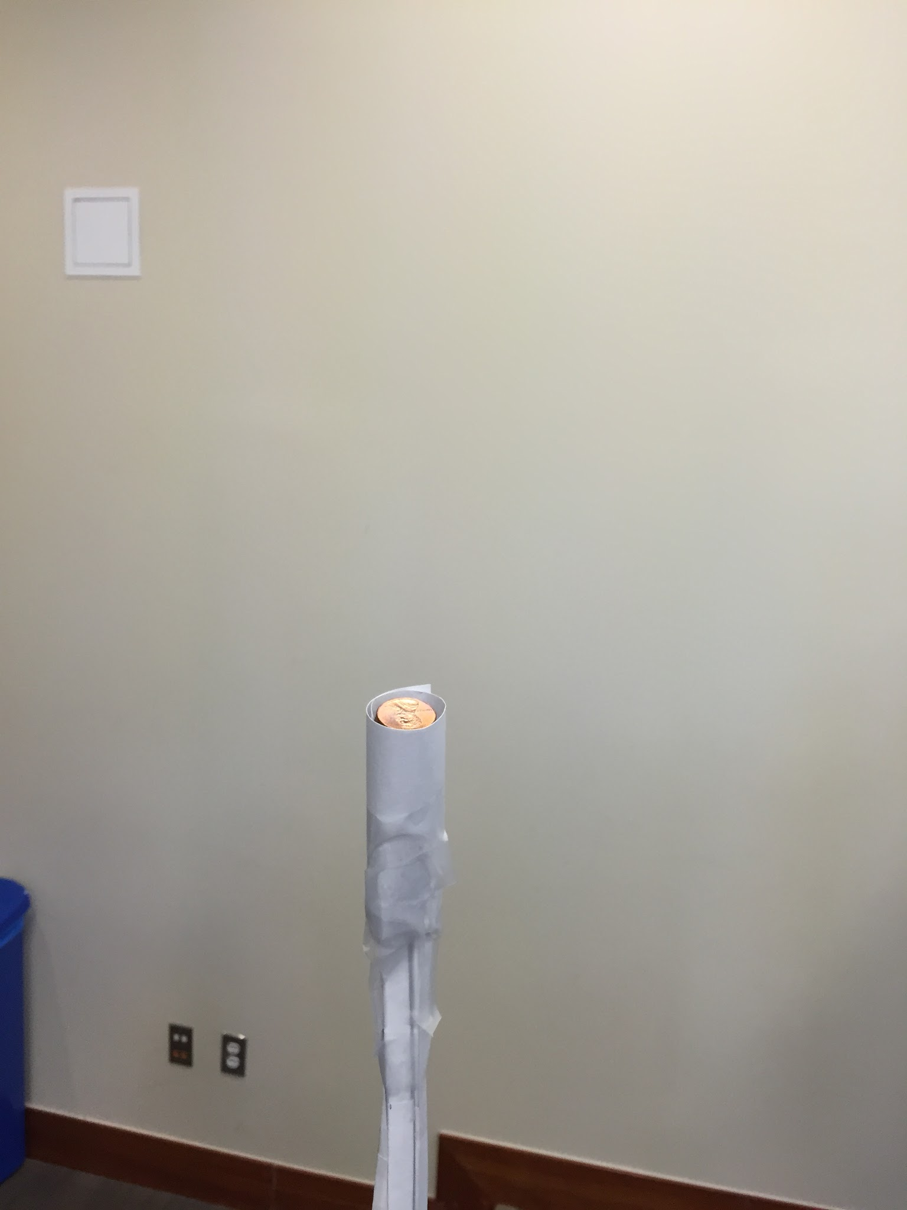

**CALCULATIONS:**

* **Costs:** 
  + 35 cards x $1000 = $35000
  + 1 roll of tape used x $5000 = $5000
  + 1 pair of scissors used x $5000 = $5000
  + 13 minutes over time limit x $2000 = $26000
  + Total cost = $71000
* **Revenue:** 
  + Successful structure built meeting specifications = $100000
  + 5” above minimum height x $2000 = $10000
  + 26 additional pennies past minimum x $500 = $13000
  + Total revenue = $123000
* **Total Profit:** 
  + Total revenue - Total cost = **$52000**

**DISCUSSION:**

This project is meant to show how engineers must strive to find the perfect balance between design and economics, shown simply here through the construction of a tower made of index cards and tape. Many will have chosen to build structures that were guaranteed to hold the weight of the pennies, but required a large number of index cards to build. We chose to go a different route and build a structure containing the least amount of materials possible and still achieve the minimum requirements.   
 Our choice came with a high risk element to it, as the structure we decided to build, while theoretically strong and capable of supporting the specified load, appeared considerably weak and possibly unable accomplish the minimum requirements after construction was complete. Our risk did pay off, however, as the structure met all requirements and exceeded in strength.

One of the major negatives of our structure was the time it took to construct, going 13 minutes over the specified time limit and adding a considerable amount of extra cost to the overall project. Additionally, our overcompensation of index cards cost us roughly $15000 due to unused cards, which could have been avoided by going with our initial calculations. However, in the real world, it is better to go a little over what is required to ensure a safety net should something go wrong during construction or possible errors made in calculations.

One flaw we found in our structure was the small amount of room for the pennies to be placed at the top. This prevented the structure from holding any amount of pennies past 36. If the cylinder at the top were larger, greater profit could have been seen through more pennies being held up.